**22.Calculate income tax**

**Exercise**

* **Calculate income tax paid by you to the government as per the slabs mentioned below:**

**Income Slab           Tax**

**2.5L – 5.0L              5%**

**5.0L – 10.0L             20%**

**Above 10.0L               30%**

**Note that there is no tax below 2.5L. Take the input amount as input from the user.**

**Approach:**

**So here we did like this**

**Java: Ctrl + “+” = zoom**

**Python : Simple use of if, elif, else methods**

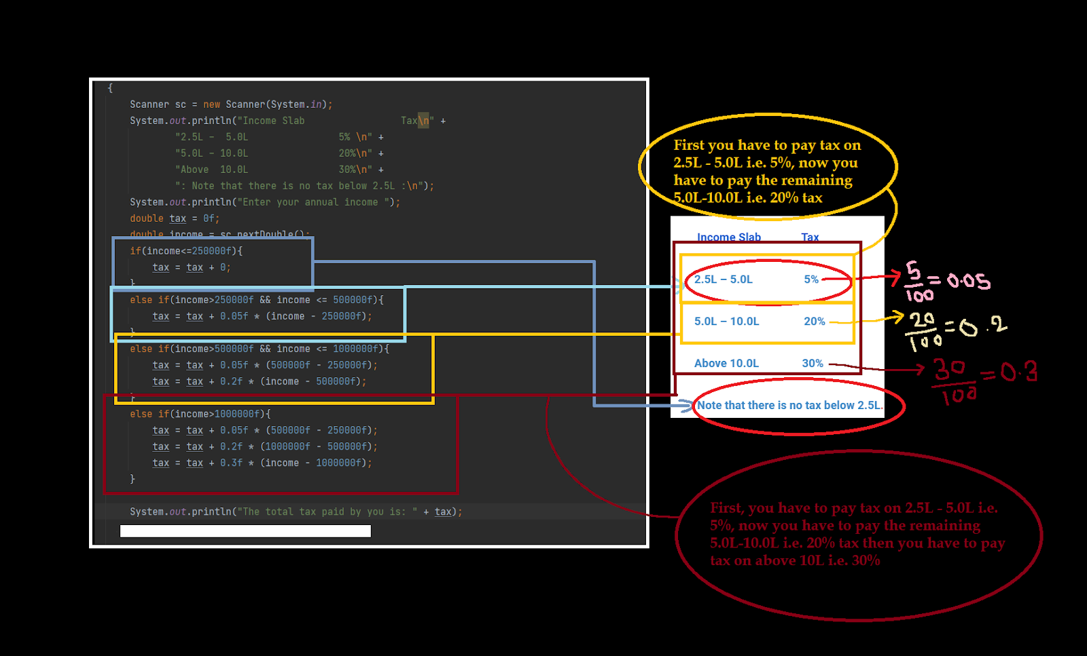

**Solution 👇**

**Java :**

**import java.util.Scanner;**

**class CodeXam**

**{**

**public static void main(String [] args)**

**{**

**Scanner sc = new Scanner(System.in);**

**System.out.println("Income Slab                 Tax\n" +**

**"2.5L –  5.0L                5% \n" +**

**"5.0L – 10.0L                20%\n" +**

**"Above  10.0L                30%\n" +**

**": Note that there is no tax below 2.5L :\n");**

**System.out.println("Enter your annual income ");**

**double tax = 0f;**

**double income = sc.nextDouble();**

**if(income<=250000f){**

**tax = tax + 0;**

**}**

**else if(income>250000f && income <= 500000f){**

**tax = tax + 0.05f * (income - 250000f);**

**}**

**else if(income>500000f && income <= 1000000f){**

**tax = tax + 0.05f * (500000f - 250000f);**

**tax = tax + 0.2f * (income - 500000f);**

**}**

**else if(income>1000000f){**

**tax = tax + 0.05f * (500000f - 250000f);**

**tax = tax + 0.2f * (1000000f - 500000f);**

**tax = tax + 0.3f * (income - 1000000f);**

**}**

**System.out.println("The total tax paid by you is: " + tax);**

**}**

**}**

**output:**

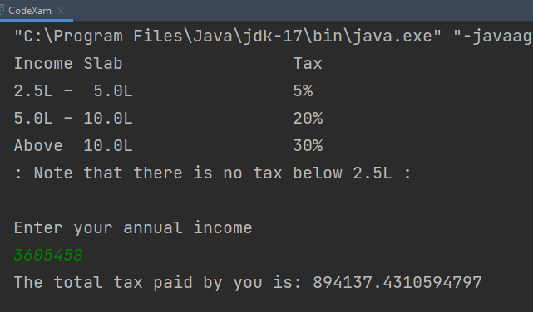

**Python :**

**print("""         Income Slab                Tax**

**============                ====**

**2.5L –  5.0L                5%**

**5.0L – 10.0L                20%**

**Above  10.0L                30%**

**\* Note that there is no tax for income below or equal to 2.5L *""")**

**income = int(input("\nEnter your annual income:\n"))**

**tax1 = (5/100)**

**tax2 = (20/100)**

**tax3 = (30/100)**

**sentence = "Your annual tax is"**

**if income <= 250000:**

**print("You have no annual Tax charge !")**

**elif 250000 < income <= 500000:**

**tax = ((income-250000)*tax1)**

**elif 500000 < income <= 1000000:**

**tax = ((500000-250000) * tax1 + (income - 500000)*tax2)**

**else:**

**tax = ((500000-250000) * tax1 + (1000000 - 500000)*tax2 + (income - 1000000)*tax3)**

**print(sentence, tax)**

**output:**

